Devan Booy

ZONKE TECH

# **Automatic Number Plate Recognition using Tensorflow and EasyOCR**

**Background**

We have a system in place at a secure business complex, where we allow/deny access to inbound vehicles based on the vehicle number plates. We have a vehicle management system that keeps track of allowed vehicles. We also have a list of stolen vehicles. If the vehicle trying to enter the complex is stolen, we will need to kick off an automated sms/email notification to alert head office/SAPS that the stolen vehicle has been identified at the premises.

**Task**

Allow a user to capture the vehicle number plate and confirm it that the vehicle is allowed access. If the vehicle is marked as stolen, perform the appropriate action.

**Bonus Task**

Using OCR, take a picture using the camera of the device to recognise the vehicle number plate

**Project summary**

* Install / setup environment as well as dependencies
* Getting number plate data
* Training object detection model
* Detecting number plates
* Applying OCR to text
* Output region of interest and results

**How is it going to work?**

* First up I will use Object Detection to find a Region of Interest
* Then I will use Easy OCR to extract the text
* Real time webcam feed grabs image of a plate (I will also use an existing image)
* Tensorflow Object Detection will be used to detect the plate, trained on a Kaggle dataset. <https://www.kaggle.com/datasets/andrewmvd/car-plate-detection>
* I also created my own annotated dataset with South African number plates to improve model accuracy.
* Finally use Easy OCR to extract and leverage a size filtering algorithm to grab the largest detection region.

**Results**

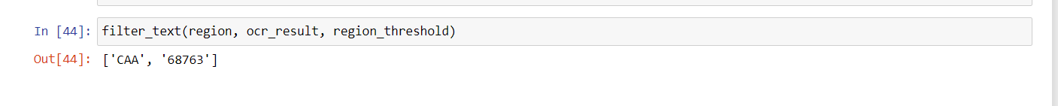If the vehicle number plate is allowed access, the following should display:

If the vehicle is stolen, the following should display:

